Ka Hou Lou

**How to Change Violin Strings**

So your violin string snapped, or you simply want a change of strings. Violins are delicate instruments, and if you’re like me, changing strings for the first few times was a daunting task. This will be a brief tutorial to walk beginners through the process of replacing strings. In just a few steps, you’ll be able to play your violin again!

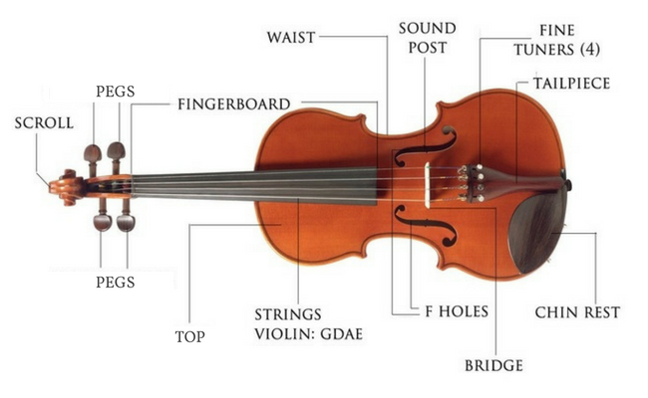

*Refer to the image above if you are not familiar with the names for violin parts.*

**Disclaimer**: Everyone does things differently, but this will be the gist of the process. Eventually, with practice and a couple of tries, you can adjust and create your own ways of changing strings!

**Getting the Right String**

Before you can change your strings, you need to make sure you have the right strings. Strings are specific to their instrument, and each of the four strings in the violin are not interchangeable. Below are the general steps and some tips in getting the right string.

**Determine Which String to Replace**

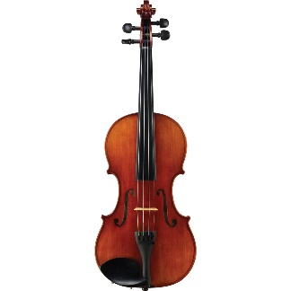

1. Hold the violin face up with scroll on top. A picture of this position is show above. For the rest of this tutorial, this perspective of the violin will be used to locate the parts on the violin and will be referred to as the ‘face-up position’
2. Identify which string you are replacing. In the picture above, the four strings from left to right are respectively G, D, A, and E.

**Determine ‘E’ String Ball End or Loop End**

**Note**: Skip this step if you are not replacing the ‘E’ string because all other strings will have Ball Ends.

Depending on your violin, you may need a Ball End or a Loop End for your ‘E’ string. An image is provided below to give a sample comparison between the two.

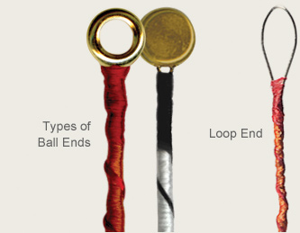

1. Examine the fine tuner for your ‘E’ string.
   1. Two prong: Note the two metal pieces on the sides of the ball end of the string.

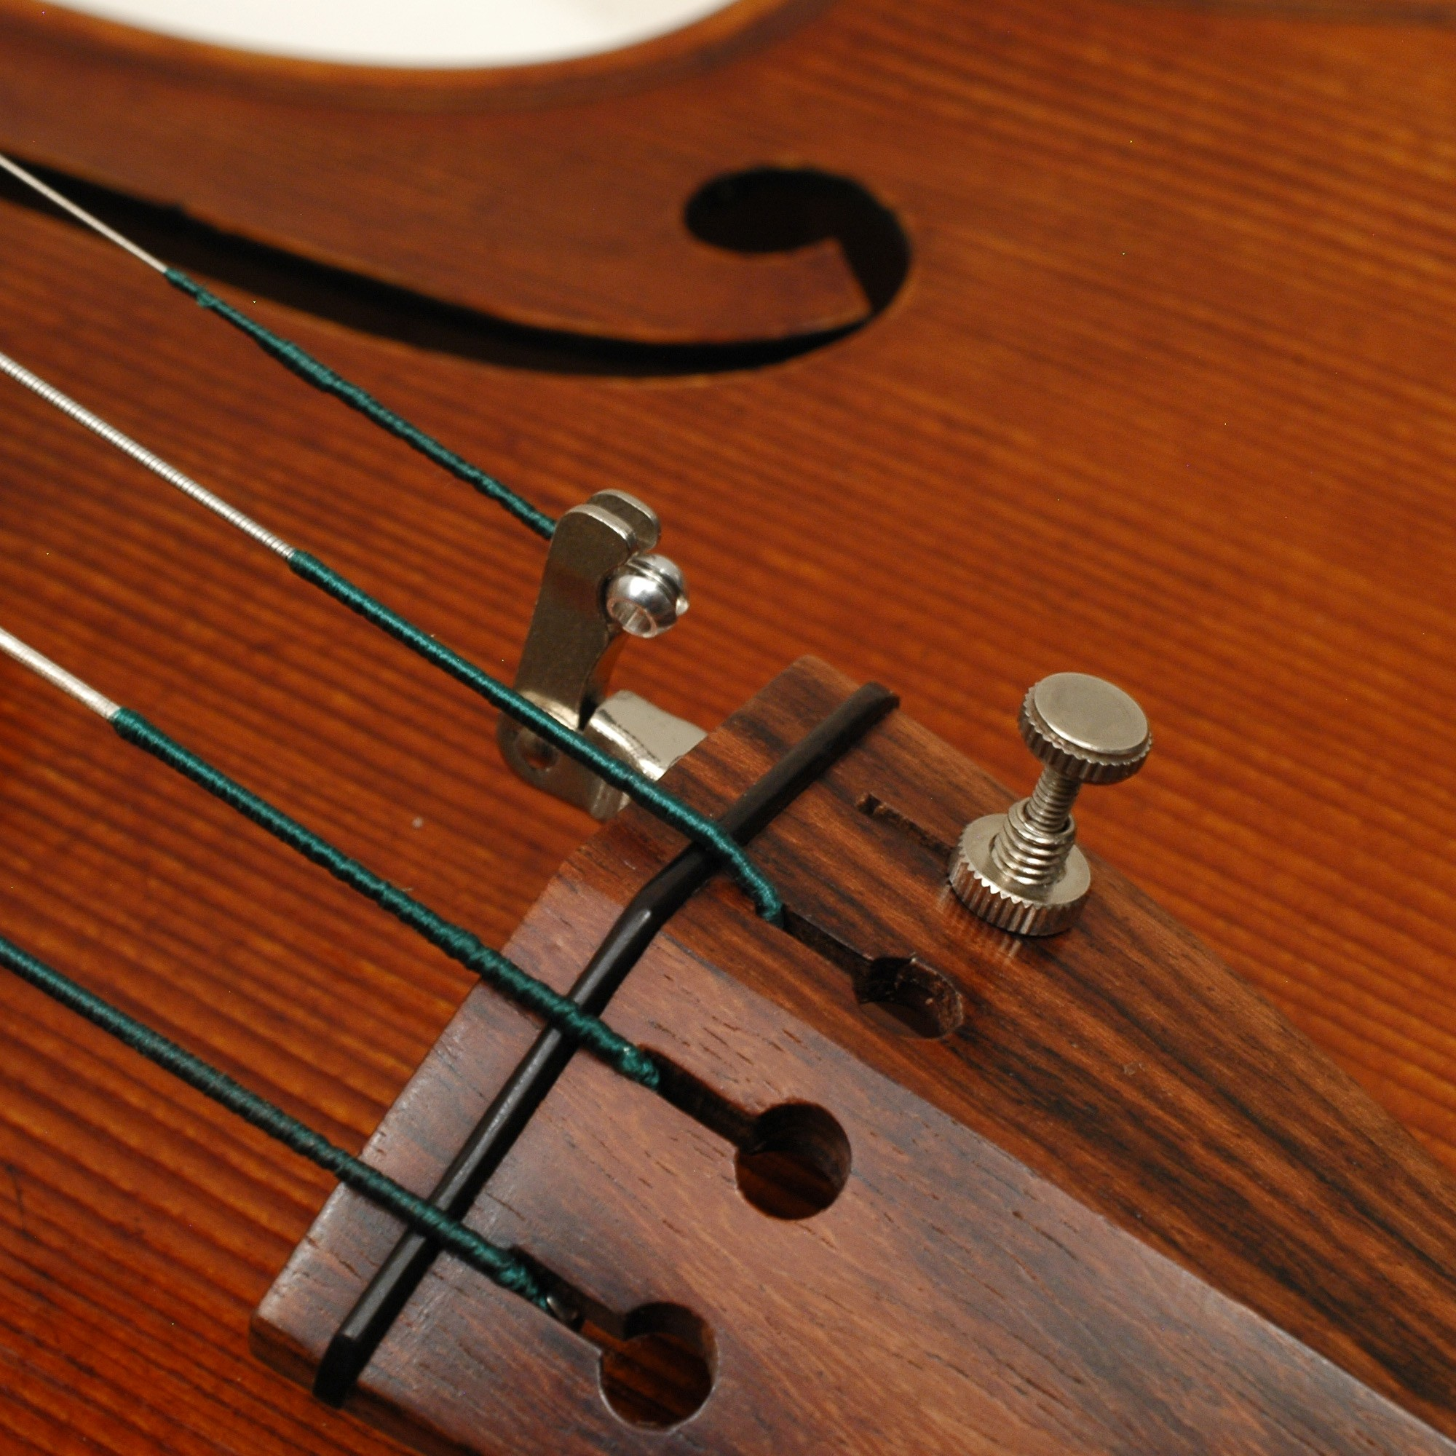

* 1. Single hook: It is simply a hook to hold the loop in place.

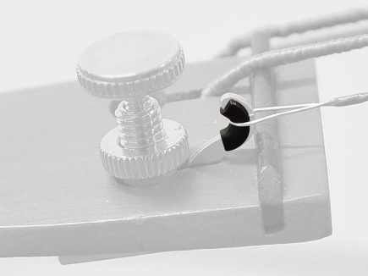

**Note:** If you happen to have a loop end string for a violin that uses ball ends, it is possible to loop your string on one of the two prongs, though this is heavily advised against because it’s more likely to damage your string.

**Order your String**

Keep in mind that the string you get makes a huge difference! It is recommended for beginners to get strings that correspond with the brand and type of the other strings. Any brand of strings will work, though the sound and feel may be off.

**Removing the Old String**

**Holding the Violin**

Before we remove the string, lets hold the violin in a stable position. This is to prevent any accidents or damage to the instrument.

1. Choose a place where you can sit to change the string. We will be using our knees to support the instrument, so a stable chair is recommended.
2. Pick up the violin by the fingerboard area between the pegs and body of the violin. Bring the violin over to the seat with the violin still held by the fingerboard.
3. Move the violin to above your legs and position the circular button located under the tail piece firmly on the mid-section of a thigh.
4. With your other hand, grab the top body of the violin (the area near the bottom of the fingerboard and above the f holes. Once the violin is held by the body, you can now let go of the hand on the fingerboard.

**Locating the Peg and Adjusting Position**

In the case where the string didn’t break, it might be a little tricky determining which peg you are working with. After figuring this out, we will adjust our holding position accordingly

1. There are two easy methods to determine which peg corresponds to which string
   1. Simply follow the string up to the scroll and track which peg the string winds up to.
   2. Almost all violins have their pegs in the same position. You can refer to the list below to figure out which peg belongs to which string.
      1. G string is on the bottom left
      2. D string is on the top left
      3. A string is on the top right
      4. E string is on the bottom right
2. After locating the peg, note which side of the violin the peg is on. Also note which side of the body you are currently using to hold the body of the violin. (NOTE: Side refers to the left and right side divided by the fingerboard)
   1. If you are holding the violin on the side opposite of the peg, skip this step and move on to ‘**Removing the String**’ section.
   2. If the peg is on the same side as the side of the violin being held by your hand, switch the hand you are using to hold the violin. (CAUTION: Use both hands to hold each side of the violin before switching hands.)

**Removing the String**

Now that we have the violin in position, we are ready to remove the string.

1. With your free hand, use two fingers to hold on the knob of the peg corresponding to the string to remove.
2. With the face of the violin facing you, test using a small force which way to turn the peg to loosen it. After figuring this out, keep turning the peg until the string is sufficiently loose.
3. Without forcing it, try to unravel the string from the scroll. If any resistance is encountered, stop and loosen the peg more and try again.
4. With the string unraveled from the scroll, it should be easy to remove it from the fine-tuner end. If necessary, simply push some of the string towards the bottom of the violin tail-piece of the violin and draw the ball or loop out of fine tuner.

**Installing the New String**

We are not ready to install the new string! For this section, we will need to use both hands. As such, adjustments need to be made on holding the violin. We will still keep our violin on our laps but will not be able to use our hand to hold the body of the violin. Instead, try to keep some support behind the violin with a hand or some fingers, especially when you are applying force from the front.

**Starting from the Top**

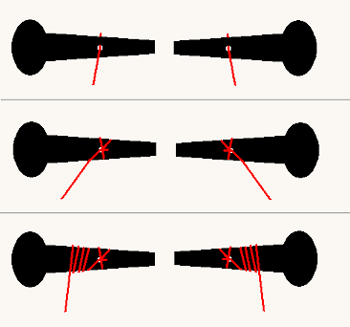

1. On the peg, look for the small hole. Thread the end of the string (the end without the ball or loop) through the peg-hole until there is about 2 millimeters sticking out from the other side of the peg.
2. We can now use the peg to start winding in the string. For the left pegs (Strings G and D), turn the peg counter-clockwise, while for the right pegs (Strings A and E), turn the peg clockwise.
3. For the first loop, wind the string towards the fingerboard (away from the knob of the peg) and the second loop in the opposite direction on top of the first loop. If this is done correctly, an ‘X’ should be created by the strings as shown in the second part of the diagram above. This is done to help against the string slipping out of the peg.
4. Continue winding away from the fingerboards towards the knob on the peg. Try not to overlap the string as you wind it and keep it neat and parallel like in the diagram above.
5. Keep winding until the string comes to the edge of the pegbox. This leaves enough of the string to attach to the tailpiece.

**Attaching the String to Tailpiece**

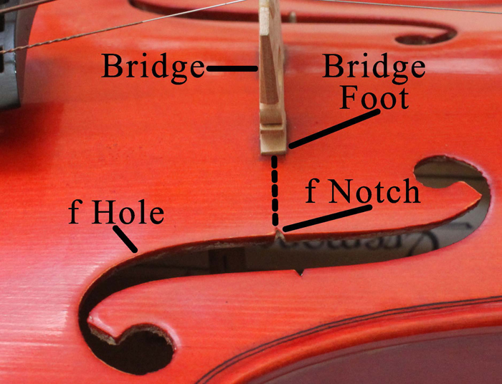

1. From the scroll, use two fingers to run down the string to remove and twists all the way down to the tailpiece.
2. Make sure the bridge on the violin is still straight up and aligned with the f Notches like the image above.
3. Place the string over the indent on the bridge for the appropriate string.
   1. For the loop end string, simply hook the loop onto the hook.
   2. For the ball end string, place the string between the two prong adjusters and let the ball rest on the two prongs.

Congratulations! You have successfully installed a new string on your violin. Now tune your violin and adjust the length of the string as necessary.